DRINKSTONE PARISH COUNCIL
MINUTES
of an Ordinary Meeting of the Council held on
Monday 7th January 2019
Present: Cllrs Cousins, Lambert, Moss, Schofield, Thurlow, Youngs (Chairman)
Attending: District Council Ward Member Cllr Penny Otton
Parish Clerk Mrs Hilary Workman
4 members of the public
19.01.01 Noted:
Apologies for absence were received from Cllr Hembra
19.01.02 Noted:
That there were no Members’ Declarations of Local Non-Pecuniary Interests and/or
Disclosable Pecuniary Interest in subsequent Agenda items and no additions
and/or deletions to the Council’s Register of Interests.
19.01.03 Resolved:
That the Minutes of the Parish Council meeting held on 3rd December 2018,
as tabled, be agreed as a true record.
19.01.04 Noted:
Correspondence to this meeting not dealt with as an Agenda item or in the Clerk’s report.
4.1 Mid Suffolk District Council
4.1.1 That MSDC had supported funding for two PCSO’s.
4.1.2 A review of Polling Districts, Polling Stations and Polling Places – no change to Drinkstone Polling Place (circulated).
4.2 Suffolk County Council
4.2.1 A Consultation to understand equality impacts resulting from proposed changes to CAB grant funding – no action was determined.
4.2.2 Suffolk Highways notice of road repairs, Drinkstone & Rattlesden Road.
4.2.3 SCC Highways re-affirmed commitment to service improvements.
4.2.4 Suffolk Flood Risk Management Partnership publication of new guide “Riparian Ownership in Suffolk” (Circulated).
4.2.5 Community Energy and Neighbourhood Plan Workshop – 24/01/2019 (circulated).
4.3 Suffolk Police & Crime Commissioner
Consultation on raising PCC precept for 2019/20 (circulated) – the Clerk had passed the consultation to the WebMaster for publication.
4.4 National Association Local Councils (NALC)
4.4.1 NALC had advised that Council Tax Referendum Principles would not be extended to local (parish and town) councils in 2019/20.
4.4.2 NALC had introduced a new pay spine effective from 2 April 2019 – this information had been taken account when preparing the 2019/20 budget.
4.4.3 NALC had published a range of new materials to help local councils promote the 2019 Parish elections, including editable posters and flyers, a revised version of All about Councils, a press release template and timetable covering
the activities for elections – the meeting agreed the Clerk would review these materials and report back to the next meeting.

4.5 Correspondence from local resident regarding request for level access to “the Cricket” for motorised accessibility scooter. The meeting agreed that the Clerk would report this access issue to Suffolk County Council.
19.01.05 Noted:
The following reports and matters arising;
5.1 A written report from District and County Council Ward Member Cllr Penny Otton (circulated) who further reported that:
    - An on-line petition against cuts to Citizens Advice Bureau had commenced.
    - The funding for the two additional PCSO’ in Mid Suffolk was now in place and that Cllr Otton was working to ensure that this additional resource was not just concentrated in Stowmarket.
    - A new policy on trees management at MSDC meant that any proposal to fell a tree must go out to consultation.
    - Work was progressing on a district Community Strategy.
    - There was no further news on adoption of the revised Local Plan.
5.2 An oral report from Cllr Schofield noting nothing to report.
5.3 There was no report from Cllr Hembra who had sent his apologies.
19.01.06 Noted:
That when any public comment or questions were invited on any Agenda item, there were none.
19.01.07 Noted:
7.1 That the application for Locality Funding from Cllr Otton had been granted and the materials purchased by Drinkstone Green Allotments to undertake the works identified. Cllr Lambert extended her thanks on behalf of Drinkstone Green allotments to Cllr Otton and reported that all the works had now been completed.
7.2 The renewal of the Data Protection Fee due to Information Commissioner’s Office
7.3 The sad passing of Ray Bland, respected by all who knew him.18.09.08
19.01.08 Noted:
The authorised payments listed below:
 | Description | £ | Santander Chq No.
8.1 | Clerk Salary Period 8 | £171.60 | 000509
8.2 | Top Gardens #6 | £75.00 | 22000
8.3 | Gary Hembra - Refund of Online Playgrounds Invoice SIN026481 | £24.48 | 22001
8.4 | Gary Hembra - Refund of Online Playgrounds Invoice SIN026414 | £382.80 | 22002
8.5 | Gipping Press Ltd: Printing of NP Questionnaire | £238.80 | 22003
8.6 | Reimbursement of NP Stationery expenses to T Schmitt | £71.96 | 22004
8.7 | Lindi Belfield – Reimbursement of NP expenses | £6.88 | 22005

19.01.09 Resolved:
That the payment of expenses incurred below be authorised:
9.1 Information Commissioner’s Office Data Protection Fee – £40.00
19.01.10 Noted:
The current account balances and reconciliation, as scheduled, and the Chairman’s confirmation that they were supported by relevant Bank Statements.
19.01.11 Resolved:
That the council approve an increase of hours for the Parish Clerk from 4 to 5 hours per week with immediate effect.
19.01.12 Resolved:
That Drinkstone Parish Council directs Mid Suffolk District Council to pay the sum of £8,790.00, being the Parish Council’s total precept requirement for the financial year commencing 1st April 2019.
19.01.13 Noted:
Planning results as notified by MSDC
13.1 DC/18/04574 – Application for Planning Permission
Full Planning Application – Erection of stable block, extended driveway and new Cart Lodge garages (amended scheme to that approved under DC/18/01801
Meade Cottage, Beyton Road, Drinkstone IP30 9SS
Approved: DPC Supported
19.01.14 Noted:
Planning applications as notified by MSDC for comment:
14.1 DC/18/05249 – Outline Planning Permission (all Matters reserved)
Erection of 3 No. Dwellings (following demolition of barn).
Land North of Street Farmhouse, Drinkstone, Bury St Edmunds IP30 9SR
Councillors determined to object to the application for the following reasons:
Access:
The site in question is accessed along a narrow unadopted lane with very poor visibility at the junction with the highway.

In their comments, Suffolk CC Highways Department specified detailed conditions regarding sightlines and splays where the development site meets the unadopted lane. However they do not appear to have evaluated the sight lines and visibility at the junction with the highway. We attach a photograph (1) showing the approach to the junction with the lane from Beyton, where the visibility is zero. Also a photograph (2) showing the view from the lane onto the highway, showing that any traffic approaching from Beyton would be invisible to anyone trying to exit the lane.

The lane is currently an unadopted no through road with little or no traffic. Any increase in vehicle movement at this blind junction would, in our view, represent a danger to road users. Given that residents would be wholly reliant on private cars for the activities of daily living, the development would result in a minimum of 6 vehicle movements a day, not counting visitors, delivery vans and council service vehicles. It is the Council’s view that the risk attached to these extra vehicle movements at this blind junction outweighs any benefit accruing from this development.

The junction with the highway is also subject to regular winter flooding from a tributary of the Blackbourne with runs alongside it.

Drinkstone Parish Council ask that MSDC request that Highways perform a full assessment of the suitability of this junction to safely accommodate increased traffic.

The mature hedge which block visibility is part of the curtilage of a Grade II listed building in private ownership, and cannot be reduced or otherwise altered without materially affecting the amenity and setting of a listed building.

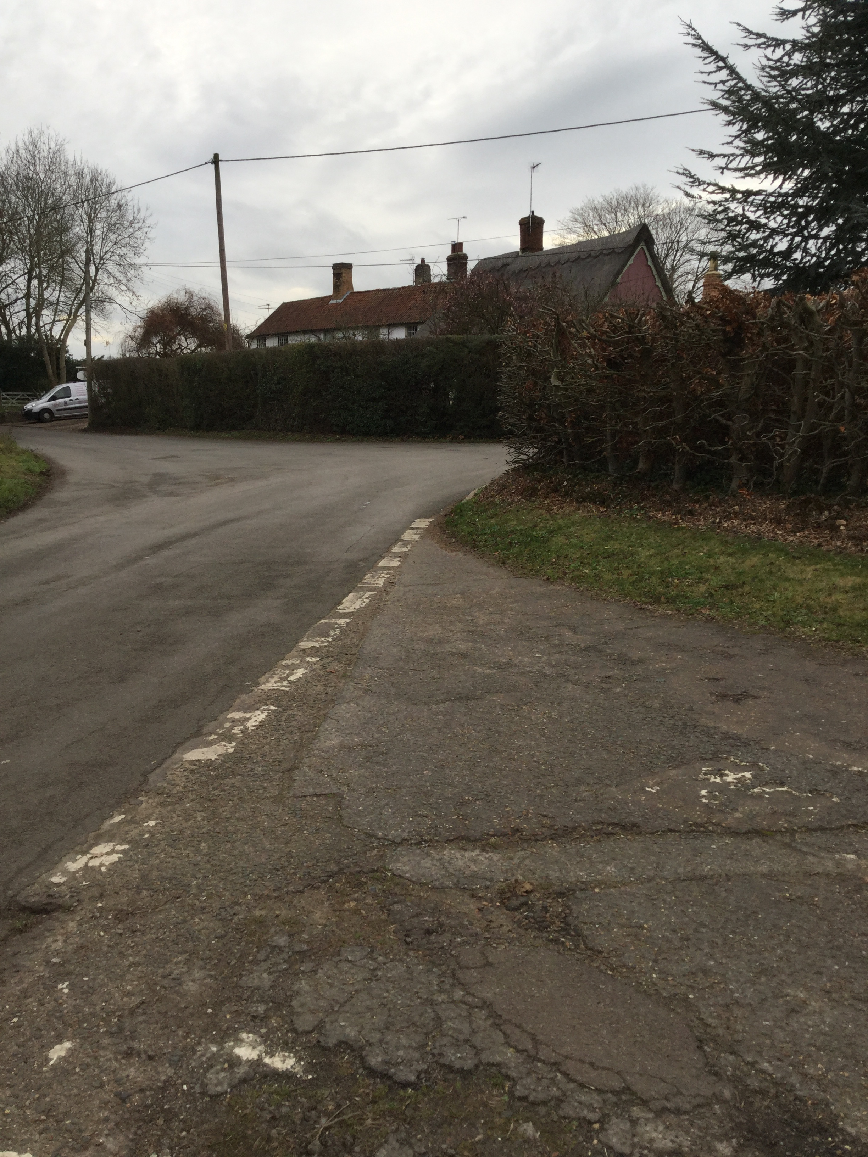 | 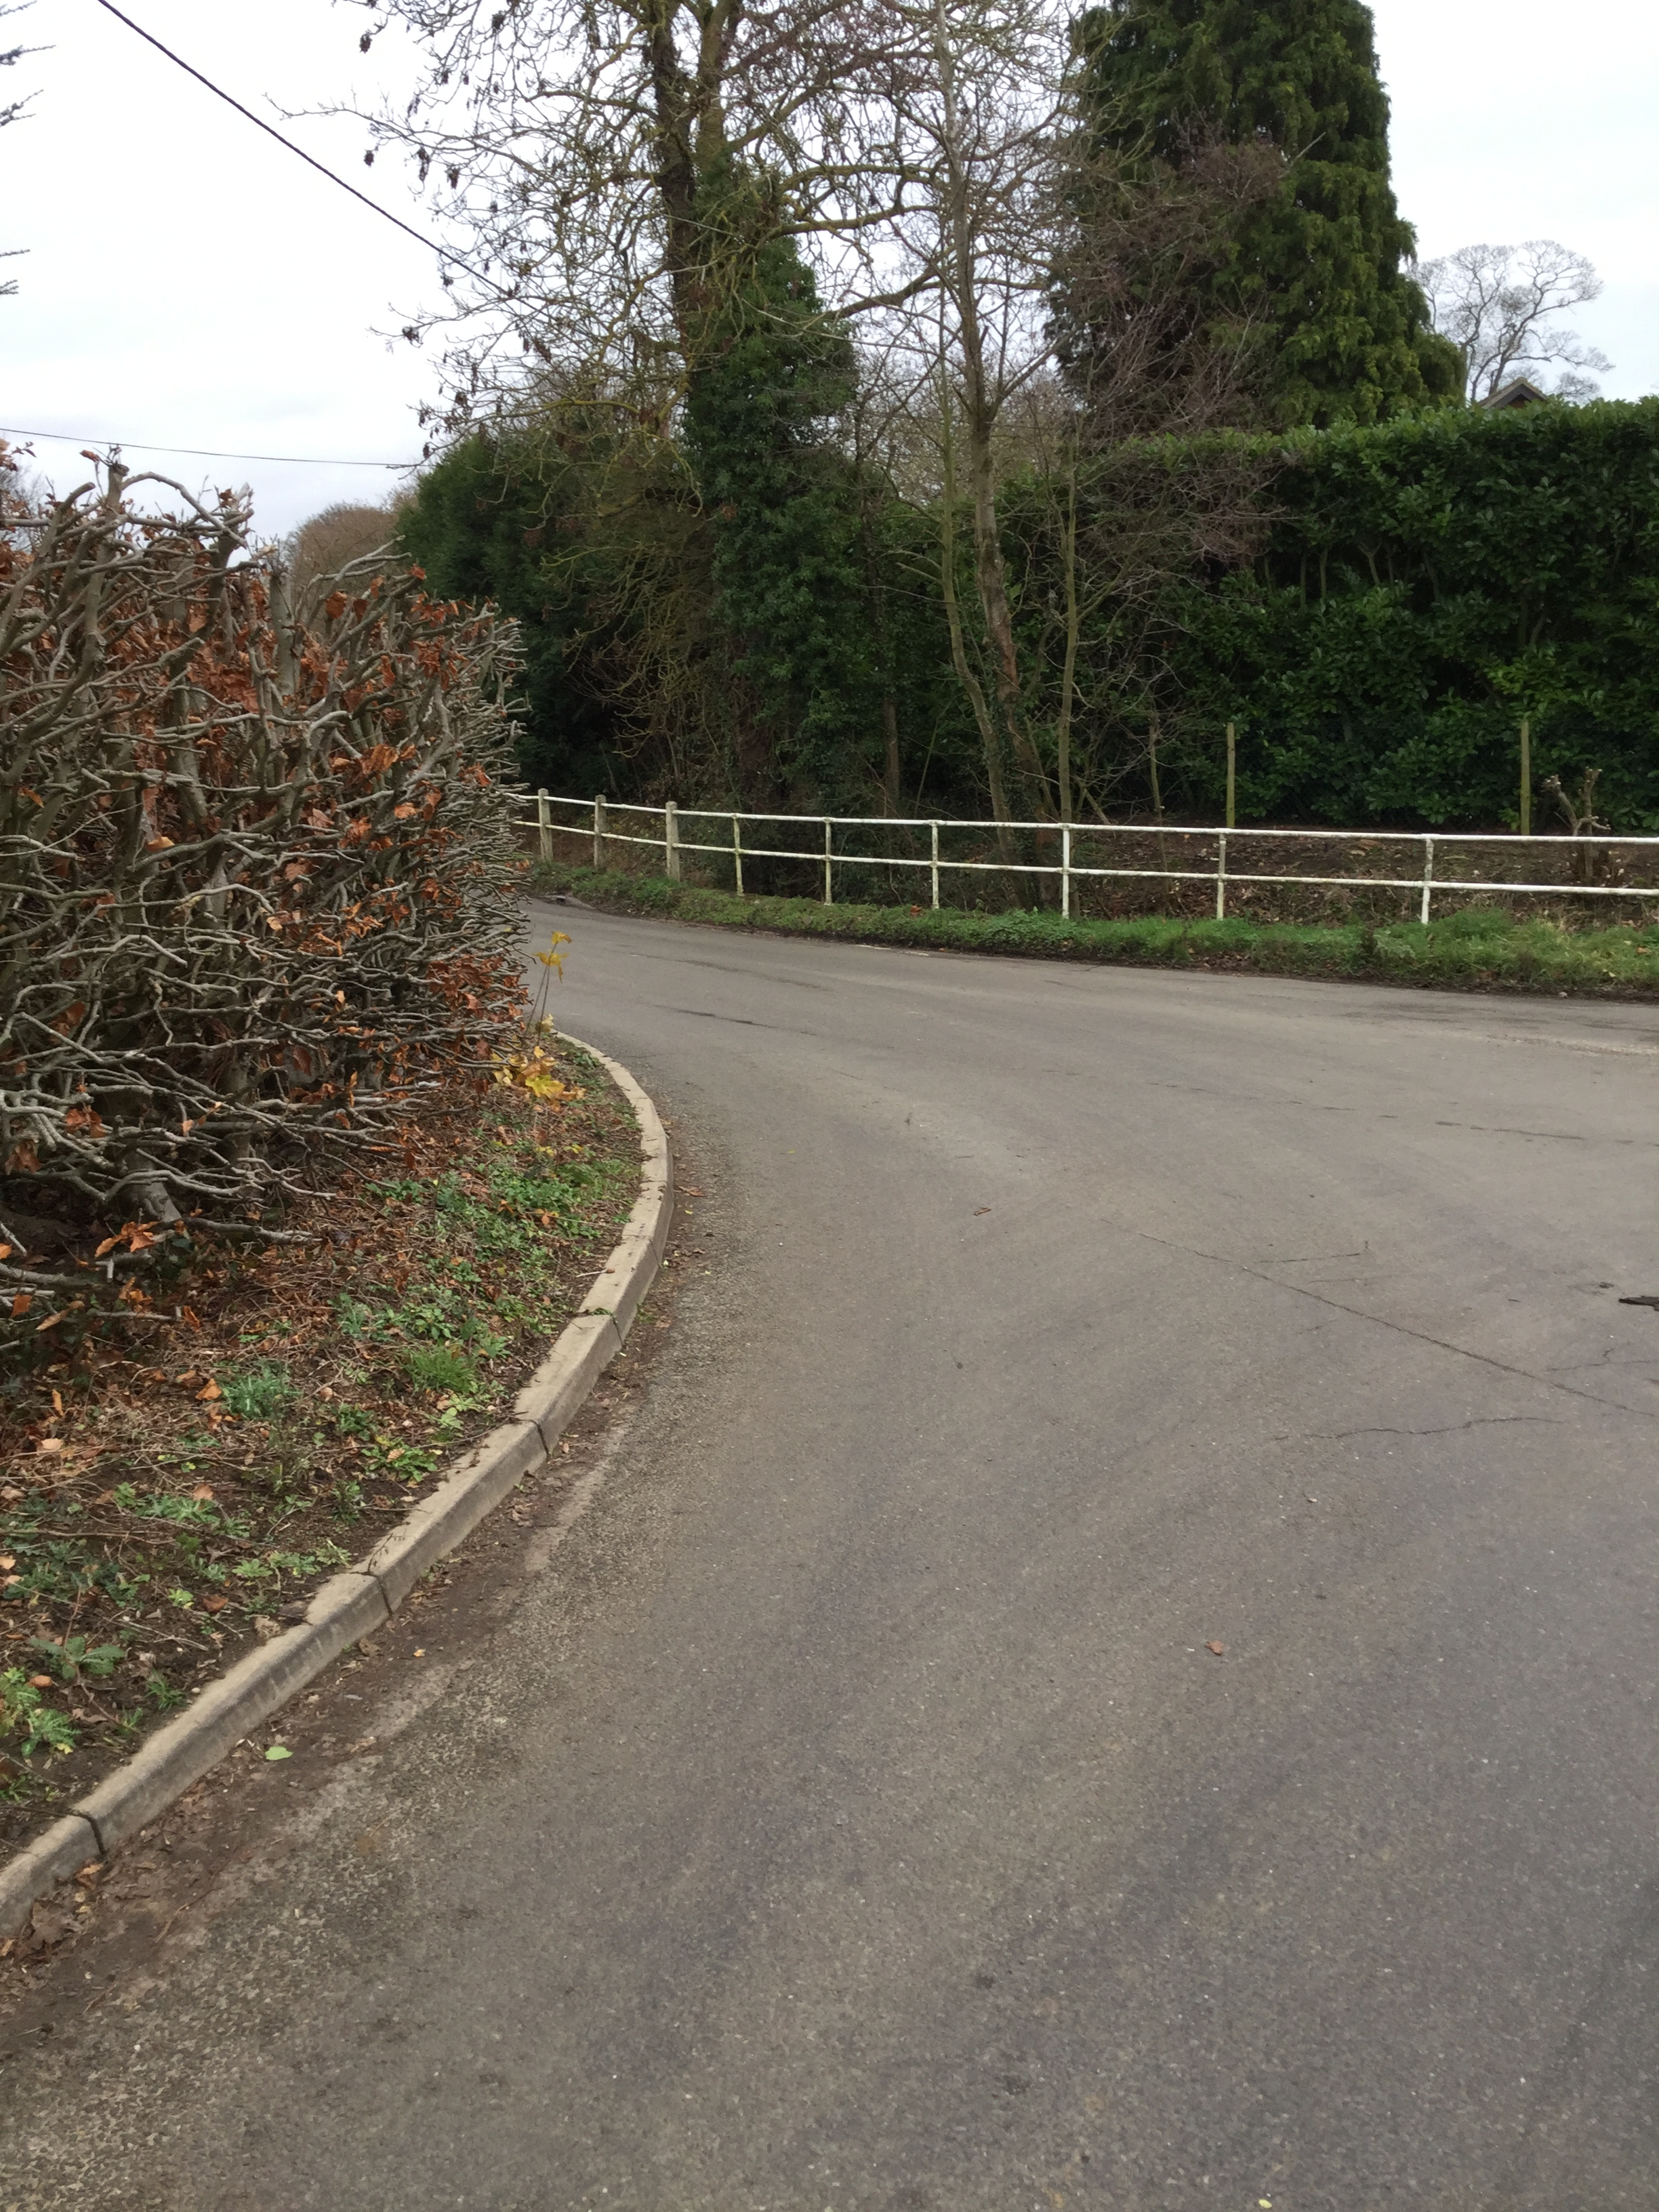
Photograph 1  Junction of unadopted lane and highway, looking west. Highway indicated with arrow. | Photograph 2  View of junction looking East from the highway. Position of junction indicated with arrow.
Housing Need:
The applicant claims that there is an identified need for new houses in this location. No such need has been identified apart from the requirement for Mid Suffolk as a whole to generate a 5 year land supply.

Initial results from our emerging Neighbourhood Plan indicate a very limited need over the next 5-10 years for smaller homes for young first time buyers or older people wishing to downsize. This is not what is being proposed here, so a need for this type of dwelling in this poorly served location cannot be identified.

A full housing needs survey carried out in 2008 to assess the need for affordable housing on the site in question, also found no need from local people for housing in this location.

14.2 DC/18/05409 – Outline Planning Application (some matters reserved)
Erection of 1 No. Dwelling, cart lodge & creation of vehicular access
Abbots Lodge, The Street, Drinkstone, Bury St Edmunds, IP30 9SX
Councillors determined not to comment on this application.
14.3 Resolved:
That Drinkstone Parish Council make known to the Corporate Manager, Growth & Sustainable Planning, at Mid Suffolk District Council its views on the Planning application on this agenda.
19.01.15 Noted:
That there were no other planning matters for information, to be noted or for inclusion on a future agenda.

19.01.16 Resolved:
That Council appoint Messrs Heelis and Lodge as Internal Auditors for the financial year 2019/2020.
19.01.17 Noted:
An oral report from Cllr Youngs that there was nothing further to report with respect to the Neighbourhood Plan.
19.01.18 Noted:
An oral report from the Clerk advising progress on the sale of Council Land adjacent to the playing field. Burnett Barker had received confirmation that the purchasers’ solicitors had raised queries. No further updates had been received.
19.01.19 Noted:
Progress on the Registration of the Parish Lands to establish legal Title. No action was determined.
19.01.20 Noted:
An oral report from the Clerk on General Data Protection Regulations (GDPR). The Clerk was attending a course on GDPR on 15th January and continuing to assess the digital and hard copy records held by Drinkstone Parish Council.
19.01.21 Noted:
That when any Public Comment or Questions on any matter of Council business was invited, there was none.
19.01.22 Noted:
That when any other Council business for information, to be noted or for inclusion on a future agenda was invited:
22.1 Cllr Youngs reported that installation of broadband by Openreach was still incomplete and that she would ask for further support in resolving this issue from the office of MP Jo Churchill.
19.01.23 Noted:
That the scheduled date for the next meeting was Monday 4th February 2019 beginning at 8.00pm in the Village Hall.
19.01.24 Noted:
The meeting closed at 8:44pm.

